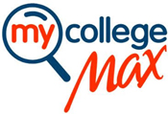

MyCollegeMax Referral Program Application

Name (Individual or Institutional):
Date:
Street Address:
City:
State: Zip:
Select One (“X” the line):
Professional: ___ Ambassador: ___ Institution: ___ Organization: ___
Briefly describe your interest in the MyCollegeMax Referral Program:
For Institution & Organization Referrals, please designate the scholarship, foundation, or service the checks will be used for:
Email form to dharvey@mycollegemax.com. All applicants must respond to any questions from MCM and complete a W9 form prior to being approved.
Please allow 1 to 2 weeks to process.

